Mass Spectrometry Data Representation (mzData) 1.05

Status of This Memo

This memo describes the Proteomics Standards Initiative (PSI) community practices regarding representation of mass spectrometry data. Distribution is unlimited.

Copyright Notice

Copyright © Proteomics Standards Initiative (2006). All Rights Reserved.

Abstract

Mass spectrometry plays an important role in the qualitative and quantitative analysis of biological molecules. mzData is an XML format for representing mass spectrometry data in such a way as to completely describe the instrumental aspects of the experiment. The key feature of the format is the use of external controlled vocabularies to allow data from new instruments and new experimental designs to be shared in a common format. The controlled vocabulary reference mechanism is described in this document, while the PSI vocabulary is described elsewhere. The format is extensible to allow the description of new instrument types; however, only mass spectrometers are described in this document.

Contents

Abstract 1
1. Introduction 4
1.1 Goals 4
1.2 Non-Goals 4
1.3 Requirements 4
1.4 Use Cases 4
1.5 Conventions 4
1.6 PSI-MS Working Group Members 6
1.7 Acknowledgements 6
2. Controlled Vocabulary 7
2.1 Parameter Type (paramType) 7
2.2 cvParam 7
2.3 userParam 8
3. Binary Data Representation 9
3.1 binaryDataGroup/data 9
4. mzData Document Structure 9
4.1 mzData 9
4.2 mzData/cvLookup 10
4.3 mzData/description 11
4.4 mzData/description/admin 12
4.5 mzData/description/admin/sampleName 12
4.6 mzData/description/admin/sampleDescription 13
4.7 mzData/description/admin/sourceFile 13
4.8 mzData/description/admin/sourceFile/nameOfFile 14
4.9 mzData/description/admin/sourceFile/pathToFile 14
4.10 mzData/description/admin/sourceFile/fileType 14
4.11 mzData/description/admin/contact 15
4.12 mzData/description/admin/contact/name 15
4.13 mzData/description/admin/contact/institution 16
4.14 mzData/description/admin/contact/contactInfo 16
4.15 mzData/description/instrument 17
4.16 mzData/description/instrument/instrumentName 17
4.17 mzData/description/instrument/source 18
4.18 mzData/description/instrument/analyzerList 18
4.19 mzData/description/instrument/analyzerList/analyzer 19
4.20 mzData/description/instrument/detector 19
4.21 mzData/description/instrument/additional 20
4.22 mzData/description/dataProcessing 20
4.23 mzData/description/dataProcessing/software 21
4.24 mzData/description/dataProcessing/software/name 21
4.25 mzData/description/dataProcessing/software/version 22
4.26 mzData/description/dataProcessing/software/comments 22
4.27 mzData/description/dataProcessing/processingMethod 22
4.28 mzData/spectrumList 23
4.29 mzData/spectrumList/spectrum 23
4.30 mzData/spectrumList/spectrum/spectrumDesc 25
4.31 mzData/spectrumList/spectrum/spectrumDesc/spectrumSettings 25
4.32 mzData/spectrumList/spectrum/spectrumDesc/spectrumSettings/acqSpecification 26
4.33 mzData/spectrumList/spectrum/spectrumDesc/spectrumSettings/acqSpecification/acquisition 26
4.34 mzData/spectrumList/spectrum/spectrumDesc/spectrumInstrument 27
4.35 mzData/spectrumList/spectrum/spectrumDesc/precursorList 27
4.36 mzData/spectrumList/spectrum/spectrumDesc/precursorList/precursor 28
4.37 mzData/spectrumList/spectrum/spectrumDesc/precursorList/precursor/ ionSelection 28
4.38 mzData/spectrumList/spectrum/spectrumDesc/precursorList/precursor/ activation 29
4.39 mzData/spectrumList/spectrum/spectrumDesc/comments 29
4.40 mzData/spectrumList/spectrum/supDesc 30
4.41 mzData/spectrumList/spectrum/supDesc/supDataDesc 30
4.42 mzData/spectrumList/spectrum/supDesc/supSourceFile 31
4.43 mzData/spectrumList/spectrum/mzArrayBinary 31
4.44 mzData/spectrumList/spectrum/intenArrayBinary 32
4.45 mzData/spectrumList/spectrum/supDataArrayBinary 32
4.46 mzData/spectrumList/spectrum/supDataArray 33
4.47 mzData/spectrumList/spectrum/supDataArray/arrayName 34
4.48 mzData/spectrumList/spectrum/supDataArray/float 35
4.49 mzData/spectrumList/spectrum/supDataArray/double 35
4.50 mzData/spectrumList/spectrum/supDataArray/int 35
4.51 mzData/spectrumList/spectrum/supDataArray/Boolean 35
4.52 mzData/spectrumList/spectrum/supDataArray/string 36
4.53 mzData/spectrumList/spectrum/supDataArray/time 36
4.54 mzData/spectrumList/spectrum/supDataArray/URI 36
Author Information 37
Intellectual Property Statement 37
Full Copyright Notice 37
References 38
1. Appendix: Controlled Vocabulary Usage 39
1.1 mzData/description/admin/sampleDescription 39
1.2 mzData/description/instrument/source 40
1.3 mzData/description/instrument/analyzerList/analyzer 43
1.4 mzData/description/instrument/detector 45
1.5 mzData/description/instrument/additional 46
1.6 mzData/description/dataProcessing/processingMethod 46
1.7 mzData/spectrumList/spectrum/spectrumDesc/spectrumInstrument 47
1.8 mzData/spectrumList/spectrum/spectrumDesc/spectrumSettings/acqSpecification/acquisition 47
1.9 mzData/spectrumList/spectrum/spectrumDesc/precursorList/precursor/ ionSelection 47
1.10 mzData/spectrumList/spectrum/spectrumDesc/precursorList/precursor/ activation 48
1.11 mzData/spectrumList/spectrum/supDesc/supDataDesc 48
2. Appendix: Base64 Encoded Data Read/Write Example 48

Introduction

XML[1] is a platform-independent means of representing structured information.

Goals

Allow arbitrary instrumentation and parameters to be encoded/referenced on a spectra list

Allow arbitrary algorithm and parameters to be encoded/referenced on a spectra list

Reference the source format or data, without having it be in the same document

Allow grouping of spectra from technical and biological replicate analytes.

Allow reference to arbitrary spectra in a document

Non-Goals

Requirements

Data format for arbitrary mass spectrometry data that is either raw or processed. The format must also be able to hold MIAPE information related to MS experiments. Lastly, the format should be general enough as to be implemented by different vendors.

Encode these different MS technologies:
• MALDI TOF-TOF
• SELDI
• Online or offline LC
• FT-ICR
• ICAT
• ITRAQ

Use Cases

User exports entire data set from mass spectrometry experiment into interchange file

User provides selected spectra to support experimental conclusions in interchange file

Conventions

In the XML schema diagrams included below, several model conventions are used:

Diagram Convention for Elements

Elements are shown in diagrams as rectangles with the element name in bold in the top half. For elements with type definitions, the type is named in the bottome half:

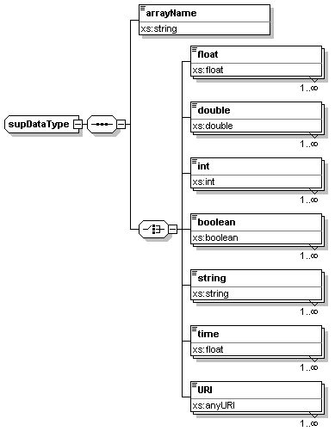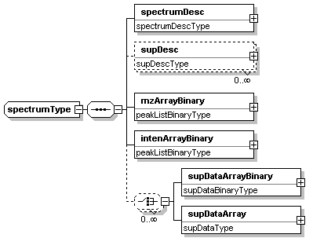

Elements are annotated with additional information such as ‘optional’ elements shown in dotted lines. Unbounded elements are shown with the 0…∞ symbol below the rectangle.

Diagram Convention for Sequences

Sequences are ordered lists of elements. Sequences are shown as:

It is important to note that sequences are ordered, in the diagram, the order is shown from top to bottom. It is a validation error to enter an element out of the order given in the sequence.

Diagram Convention for Choice

If a multually exclusive choice between elements it is specified in the schema as a choice which is shown in the diagrams with the following

If the elements beyond the choice are all optional, the choice will be shown in dotted lines, and if it is an unbounded choice, the 0…∞ is shown below the choice diagram.

Document Conventions

The key words "MUST", "MUST NOT", "REQUIRED", "SHALL", "SHALL NOT", "SHOULD", SHOULD NOT", "RECOMMENDED", "MAY", and "OPTIONAL" in this document are to be interpreted as described in RFC 2119.

For convenience, conformance requirements are called out from the main text as follows:

- Conformance (Example): Implementations MUST do something.

Non-normative notes are formatted as shown below.

Note: This is a note.

This specification uses a number of namespace prefixes throughout; they are listed in Table1.1. Note that the choice of any namespace prefix is arbitrary and not semantically significant (see XML Infoset[2]).

Prefix | Namespace | Note
xsd | http://www.w3.org/2001/XMLSchema | The namespace of the XML schema [3, 4] specification

Table 1.1

Namespace names of the general form ‘http://example.org/...’ and ‘http://example.com/...’ represent application or context-dependent URIs (see RFC 2396 [5]).

All parts of this specification are normative, with the exception of examples, notes and sections explicitly marked as ‘Non-Normative’.

PSI-MS Working Group Members

Pierre-Alain Binz, Swiss Institute of Bioinformatics
David Creasy, Matrix Science Ltd.
David Horn, Agilent Technologies
Kent Laursen, GenoLogics Life Sciences Software, Inc.
Ruth McNally, ESRC CESAGen
Sean Seymour, Applied Biosystems
Jim Shofstahl, Thermo Electron
Chris Taylor, European Bioinformatics Institute
Randy Julian, Indigo Biosystems
Patrick Pedrioli, Swiss Institute of Technology
Angel Pizzaro, University of Pittsburgh
Puneet Souda, University of California, Los Angeles

[Your Name Probably Goes Here]

Acknowledgements

Thanks to Summer Hamidian, (Indiana University-Purdue University Indianapolis) for editorial assistance with this document.

Controlled Vocabulary

Parameters in mzData are stored using a generic parameter type which allows the use of either a controlled vocabulary term (cvParam) or a user defined term (userParam). The cvParam element must contain a term which is a member of a controlled vocabulary named in a cvLookup element. User-specified parameters are generic name-value elements with no reference to a formal contolled vocabulary.

Parameter Type (paramType)

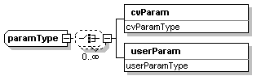

Structure allowing the use of controlled or uncontrolled vocabulary

Attributes

Name | Type | Use | Annotation

Children

Element Name | Use | Section
cvParam | required
userParam | required

cvParam

This element holds additional data or annotation. Only controlled values are allowed here.

Attributes

Name | Type | Use | Annotation
cvLabel | xs:string | required | The short tag for the resource as defined in cvLookupType.
accession | xs:string | required | The accession number of the referred-to term in the named resource.
name | xs:string | required | documentation The actual name for the parameter, from the referred-to controlled vocabulary.
value | xs:string | optional | documentation The value for the parameter; may be absent if not appropriate, or a numeric or symbolic value, or may itself be CV (legal values for a parameter should be enumerated and defined in the ontology).

userParam

This element holds additional data or annotation. Uncontrolled, or user controlled values are allowed here.

Attributes

Name | Type | Use | Annotation
name | xs:string | required | The actual name for the parameter.
value | xs:string | optional | The value for the parameter, where appropriate.

Binary Data Representation

The mzData format requires primary data (m/z and intensity) to be represented as base64 encoded binary using the W3C Schema base64Binary type [6]. To use this type, additional information is needed to decode the array properly.

The mzData format encapsulates binary data in an element called “data”. Only IEEE-754 floats are allowed in this element, however either the 32-bit or 64-bit precision floating point representation may be used. To improve cross platform interoperability, both byte orders are allowed with order specified in the “endian” attribute. Finally, the number of floating point numbers stored in the encoded array is specified in the “length” attribute.

See Section 5. for an example of working with base64 encoded arrays for this Group.

binaryDataGroup/data

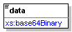

The data element which stores encoded binary data according to the base64 specification.

Attributes

Name | Type | Use | Annotation
precision | xs:string | Required
endian | xs:string | Required
length | xs:int | Required

mzData Document Structure

This section describes the elements of the mzData format. In the sections below, each of the XML elements and attributes are defined and requirements of conformance to the specification are given. The formal specification of the mzData format is a collection of XSD schema, given in appendix A.

mzData

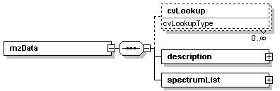

This schema can capture the use of a mass spectrometer, the data generated, and the initial processing of that data (to the level of the peak list). Peak lists are processed data from a mass spectrometry experiment. There can be multiple peak lists in an mzData file, which might be related via a separation, or just in sequence from an automated run. Any one peak list (mass spectrum) may also be composed of a number of acquisitions, which can be described individually herein.

Attributes

Name | Type | Use | Annotation
version | xs:string | required | The development version of this mzData schema.

Children

Element Name | Use | Section
cvLookup | optional | 2.2
description | required
spectrumList | optional

mzData/cvLookup

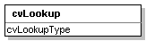

This stores the location, name, version and a short, arbitrarily assigned in-file reference label, for one or more controlled vocabulary sources. Short labels are for use elsewhere in the data file, primarily in the cvLabel attribute, to indicate the use of a particular source for an item of controlled vocabulary.

Attributes

Name | Type | Use | Annotation
cvLabel | xs:string | required | The short label to be used as a reference tag with which to refer to this particulart Controlled Vocabulary source description, from an instance of the cvLabel attribute, where it appears (i.e. in things of type paramType).
fullName | xs:string | optional | The usual name for the resource (e.g. The MGED Ontology).
version | xs:string | required | The version of the CV from which the referred-to terms are drawn.
address | xs:anyURI | required | The URI for the resource.

mzData/description

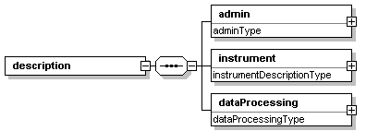

Each data set starts with a description section. This section captures 'general' information; such as the instrument on which the data were generated.

Attributes

Name | Type | Use | Annotation

Children

Element Name | Use | Section
admin | required
instrumentContainer | required
dataProcessing | required

mzData/description/admin

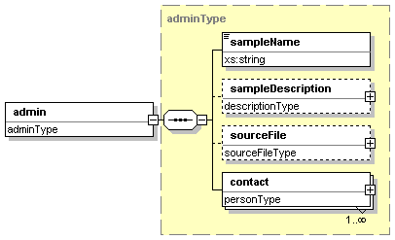

Administrative information pertaining to the entire mzData file (i.e. not specific to any part of the data set) is stored here.

Attributes

Name | Type | Use | Annotation

Children

Element Name | Use | Section
sampleName | required
sampleDescription | optional
sourceFile | optional
contact | required

mzData/description/admin/sampleName

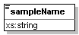

A short label that is referable to the sample used to generate the dataset. This will often be a copy of the internal (lab) reference code for the sample being analysed.

Attributes

Name | Type | Use | Annotation

Children

Element Name | Use | Section

mzData/description/admin/sampleDescription

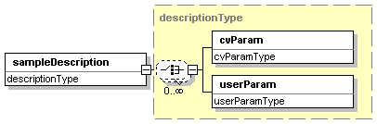

Expansible description of the sample used to generate the dataset, named in sampleName.

Attributes

Name | Type | Use | Annotation

Children

Element Name | Use | Section
cvParam | required
userParam | required

mzData/description/admin/sourceFile

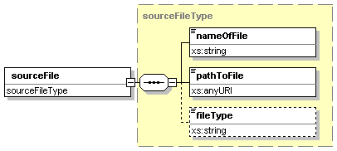

Information about the original source file (i.e. that generated by the instrument) used in generating the instance document.

Attributes

Name | Type | Use | Annotation

Children

Element Name | Use | Section
nameOfFile | required
pathToFile | required
fileType | optional

mzData/description/admin/sourceFile/nameOfFile

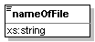

Name of the source file, without reference to location (either URI or local path).

Attributes

Name | Type | Use | Annotation

Children

Element Name | Use | Section

mzData/description/admin/sourceFile/pathToFile

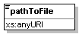

URI-formatted full path to file, without actual file name appended.

Attributes

Name | Type | Use | Annotation

Children

Element Name | Use | Section

mzData/description/admin/sourceFile/fileType

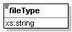

Type of the file if appropriate, else a description of the software or reference resource used.

Attributes

Name | Type | Use | Annotation

Children

Element Name | Use | Section

mzData/description/admin/contact

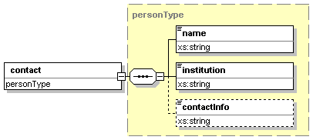

Audit information concerning the means by which the originator/owner of this mzData file can be identified, and contacted if necessary.

Attributes

Name | Type | Use | Annotation

Children

Element Name | Use | Section
name | required
institution | required
contactInfo | optional

mzData/description/admin/contact/name

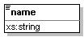

Contact person name, or role name (e.g. "Group leader of team 42") of the individual responsible for this dataset.

Attributes

Name | Type | Use | Annotation

Children

Element Name | Use | Section

mzData/description/admin/contact/institution

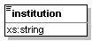

Academic or corporate organisation with which the contact person or role is associated.

Attributes

Name | Type | Use | Annotation

Children

Element Name | Use | Section

mzData/description/admin/contact/contactInfo

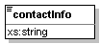

Phone number, email, postal address or other appropriate means of contact.

Attributes

Name | Type | Use | Annotation

Children

Element Name | Use | Section

mzData/description/instrument

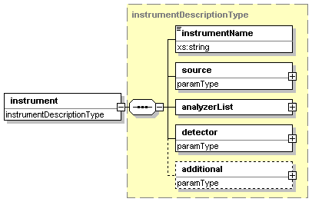

Instrument descripton (not 'run time' parameters, which should properly be captured in spectrumInstrument); these features must be common to all acquisitions.

Attributes

Name | Type | Use | Annotation

Children

Element Name | Use | Section
instrumentName | required
source | required
analyzerList | required
detector | required
additional | optional

mzData/description/instrument/instrumentName

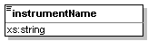

Descriptive name of the instrument (make, model, significant customisations).

Attributes

Name | Type | Use | Annotation

Children

Element Name | Use | Section

mzData/description/instrument/source

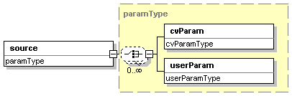

Invariant ion source (e.g. MALDI) information, as a run of name-value pairs.

Attributes

Name | Type | Use | Annotation

Children

Element Name | Use | Section

mzData/description/instrument/analyzerList

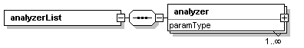

Mass analyzer component list; ordered so as to reflect the physical order of the desribed components in the mass spectrometer.

Attributes

Name | Type | Use | Annotation
count | xs:int | required | The number of analyzers that are described in the attached list.

Children

Element Name | Use | Section
analyzer | required

mzData/description/instrument/analyzerList/analyzer

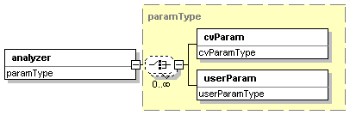

A single component of the mass analyzer (e.g. quadrupole, collision cell), decribed with a run of name-value pairs.

Attributes

Name | Type | Use | Annotation

Children

Element Name | Use | Section

mzData/description/instrument/detector

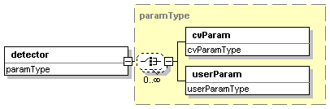

Ion detector information, as a run of name-value pairs.

Attributes

Name | Type | Use | Annotation

Children

Element Name | Use | Section

mzData/description/instrument/additional

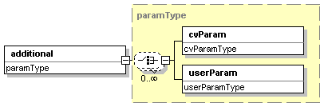

Subsidiary information about the instrument; a run of additional parameters captured as name-value pairs

Attributes

Name | Type | Use | Annotation

Children

Element Name | Use | Section

mzData/description/dataProcessing

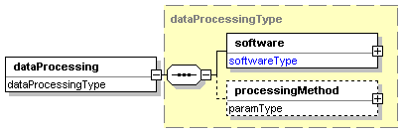

Description of the default processing by which the peak list(s) were generated.

Attributes

Name | Type | Use | Annotation

Children

Element Name | Use | Section
software | required
processingMethod | optional

mzData/description/dataProcessing/software

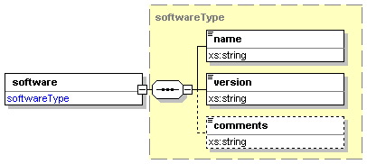

Software information (the software that produced the peak list).

Attributes

Name | Type | Use | Annotation
completionTime | xs:dateTime | optional | The time to complete the processing that resulted in this mzData file, if the mzData file was generated in a single use of the software (i.e. if the software was not used with more than one parameter set, not whether the job was completed in several phases).

Children

Element Name | Use | Section
name | required
version | required
comments | optional

mzData/description/dataProcessing/software/name

The official name for the software package used.

Attributes

Name | Type | Use | Annotation

Children

Element Name | Use | Section

mzData/description/dataProcessing/software/version

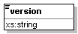

The version number of the software package.

Attributes

Name | Type | Use | Annotation

Children

Element Name | Use | Section

mzData/description/dataProcessing/software/comments

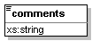

Additional comments on the use of the software.

Attributes

Name | Type | Use | Annotation

Children

Element Name | Use | Section

mzData/description/dataProcessing/processingMethod

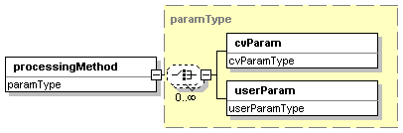

Description of the default peak processing method.This element describes the base method used in the generation of a particular mzData file. Variable methods should be described in the appropriate acquisition section - if no acquisition-specific details are found, then this information serves as the default.

Attributes

Name | Type | Use | Annotation

Children

Element Name | Use | Section

mzData/spectrumList

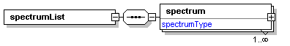
All mass spectra and the acquisitions underlying them are described and attached here. Subsidiary data arrays are also both described and attached here.

Attributes

Name | Type | Use | Annotation
count | xs:int | required | The number of spectra that are to be found in the attached list.

Children

Element Name | Use | Section
spectrum | required

mzData/spectrumList/spectrum

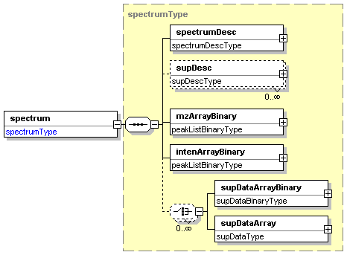

This is an individual spectrum. The spectrum is considered to be composed of an array of acquisitions. There are two primary ways of representing data; base64 encoded binary (single or double precision) or arrays of simple data types. All arrays used to describe a single spectrum are the same length, with the same indexing.

Attributes

Name | Type | Use | Annotation
id | xs:int | required | The identifier for a particular spectrum; to serve as both an internal (to the file) reference with which to order spectra and also to as a means to associate them with each other (e.g. parent and child soectra from a tandem experiment). This number should be provided whether it legitmately comes from the source data, or has to be generated. In the absence of a parent spectrum for an MS
experimentRef | xs:int | required

Children

Element Name | Use | Section
spectrumDesc | required
supDesc | optional
mzArrayBinary | required
intenArrayBinary | required
supDataArrayBinary | optional
supDataArray | optional

mzData/spectrumList/spectrum/spectrumDesc

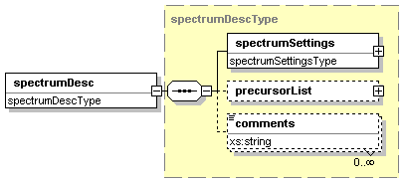

There is one spectrumDesc per spectrum. It captures both the instance-specific parameters for the underlying acquisitions, and where applicable, the postion of this spectrum in a possible hierarchy of spectra. For example, for 'tandem' mass spectrometry; the id attribute on the spectrum element allows the survey scan to be identified from which the parent ion was selected that gave rise to this MSMS spectrum - note that these identifying numbers can be given, in a list if necessary, whether or not the actual referred-to spectra are present in the file - they are the 'family tree' of this spectrum.

Attributes

Name | Type | Use | Annotation

Children

Element Name | Use | Section
spectrumSettings
precursorList
comments

mzData/spectrumList/spectrum/spectrumDesc/spectrumSettings

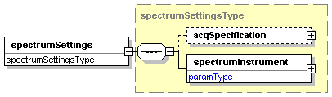

Both run time instrument settings and variations in software parameters all leading to the generation of the specific spectrum being described.

Attributes

Name | Type | Use | Annotation

Children

Element Name | Use | Section
acqSpecification
spectrumInstrument

mzData/spectrumList/spectrum/spectrumDesc/spectrumSettings/acqSpecification

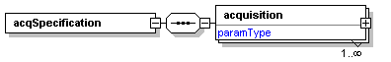

Both run time instrument settings and variations in software parameters all leading to the generation of the specific spectrum being described.

Attributes

Name | Type | Use | Annotation
spectrumType | xs:string | required | Whether these are discrete or continuous spectra.
methodOfCombination | xs:string | required | The method (most usually summing or some form of averaging) by which the acquisitions were combined to make the spectrum.
count | xs:int | required | The total number of acquisitions attached (as a simple data integrity check).

Children

Element Name | Use | Section
acquistion

mzData/spectrumList/spectrum/spectrumDesc/spectrumSettings/acqSpecification/acquisition

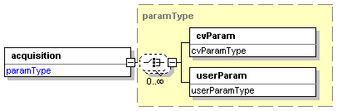

Both run time instrument settings and variations in software parameters all leading to the generation of the specific spectrum being described.

Attributes

Name | Type | Use | Annotation
acqNumber | xs:int | required | The actual acquisition number taken directly from the raw file.

Children

Element Name | Use | Section

mzData/spectrumList/spectrum/spectrumDesc/spectrumInstrument

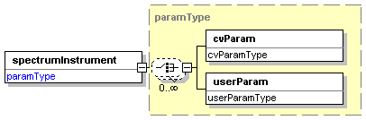

The instrument's 'run time' parameters; common to the whole of this spectrum.

Attributes

Name | Type | Use | Annotation
msLevel | xs:int | required
mzRangeStart | xs:float | optional
mzRangeStop | xs:float | optional

Children

Element Name | Use | Section
cvParam | required
userParam | required

mzData/spectrumList/spectrum/spectrumDesc/precursorList

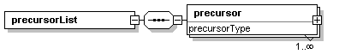

List and descriptions of precursors to the spectrum currently being described.

Attributes

Name | Type | Use | Annotation
count | xs:int | required | The number of precursor selection processes described in the attached list.

Children

Element Name | Use | Section
precursor | required

mzData/spectrumList/spectrum/spectrumDesc/precursorList/precursor

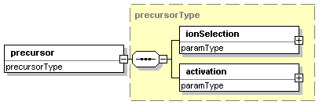

This is the precursor step. If source activation is used then both msLevel and spectrumRef have the value 0. The spectrumRef holds the value of the id attrubute of the spectrum from which the precursor ion was selected. An ordered list of these precursors can be given; the referred-to id numbers my not represent spectra present in the mzData file, but this should not present a bar to providing the history of this scan. Example (trivially); MS survey scan has id = 1 and the first MSMS spectrum has id= 2, with the spectrumRef attribute on precursor for the MSMS spectrum having the value 1.

Attributes

Name | Type | Use | Annotation
msLevel | xs:int | required
experimentRef | xs:int | optional
spectrumRef | xs:int | required

Children

Element Name | Use | Section
ionSelection | required
activation | required

mzData/spectrumList/spectrum/spectrumDesc/precursorList/precursor/
ionSelection

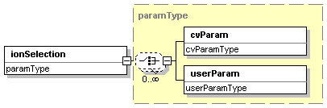

This captures the type of ion selection being performed, and trigger m/z (or m/z's), neutral loss criteria etc. for tandem MS or data dependent scans.

Attributes

Name | Type | Use | Annotation

Children

Element Name | Use | Section
cvParam | required
userParam | required

mzData/spectrumList/spectrum/spectrumDesc/precursorList/precursor/
activation

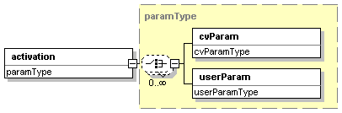

The type and energy level used for activation.

Attributes

Name | Type | Use | Annotation

Children

Element Name | Use | Section
cvParam | required
userParam | required

mzData/spectrumList/spectrum/spectrumDesc/comments

Additional comments regarding the acquisition are captured here as free text. This should only be used as a lifeboat for when the cv/userParams are inappropriate; or as a 'scratch' comment space.

Attributes

Name | Type | Use | Annotation

Children

Element Name | Use | Section

mzData/spectrumList/spectrum/supDesc

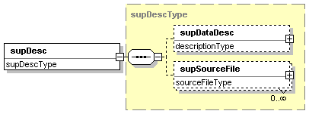

There is one supDesc for each supDataArray (binary or otherwise) found under this particular spectrum element.

Attributes

Name | Type | Use | Annotation
supDataArrayRef | xs:int | required | Reference to the id attribute of the supplemental data array/binary

Children

Element Name | Use | Section
supDataDesc | optional
supSourceFile | optional

mzData/spectrumList/spectrum/supDesc/supDataDesc

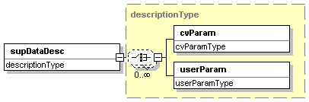

Description of the supplemental dataset, in both CV and free-text.

Attributes

Name | Type | Use | Annotation

Children

Element Name | Use | Section
cvParam | required
userParam | required

mzData/spectrumList/spectrum/supDesc/supSourceFile

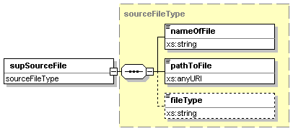

Information about the original source file used to generate the supDataArray.

Attributes

Name | Type | Use | Annotation

Children

Element Name | Use | Section
nameOfFile | required
pathToFile | required
fileType | optional

mzData/spectrumList/spectrum/mzArrayBinary

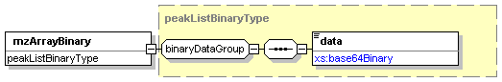

The list of m/z values (for any type of spectrum). The array is stored as a base64 encoded binary.The only type allowed is IEEE-754 floating point; the precision must be specified as either 32- or 64-bit; endianess must also be specified.

Attributes

Name | Type | Use | Annotation

Children

Element Name | Use | Section
data | required

mzData/spectrumList/spectrum/intenArrayBinary

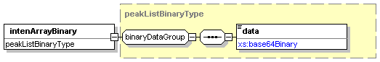

The intensities for each member of the m/z array, also in base64 encoded binary as IEEE-754 floating point, with specified precision and endianess.

Attributes

Name | Type | Use | Annotation

Children

Element Name | Use | Section
data | required

mzData/spectrumList/spectrum/supDataArrayBinary

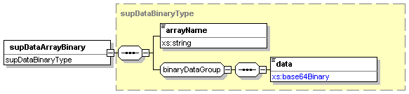

In addition to the m/z and intensity arrays, an arbitrary number of other arrays can be stored using the same indexing. For each array stored as base64 binary, precision and endianess must be specified.The only type allowed is IEEE-754 floating point (even booleans must be re-encoded this way).

Attributes

Name | Type | Use | Annotation
id | xs:int | required | The value to which the supDataArrayRef attribute on suppDesc refers; values should never be shared between binary and non-binary supplemental arrays.

Children

Element Name | Use | Section
arrayName | required
data | required

mzData/spectrumList/spectrum/supDataArray

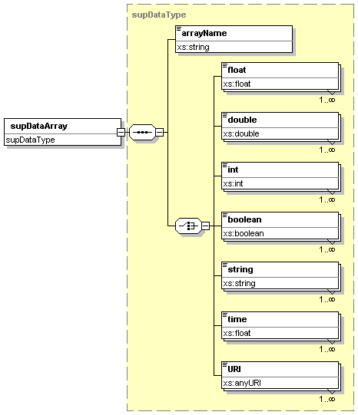

If the raw data representation method was not binary, or if the supplemental data array was a string or other non-binary type, then it can be represented in the supDataArray element (again with the same indexing).

Attributes

Name | Type | Use | Annotation
id | xs:int | required | The value to which the supDataArrayRef attribute on suppDesc refers; values should never be shared between binary and non-binary supplemental arrays.
length | xs:int | required | Number of items in the supDataArray.
indexed | xs:boolean | required | Each supDataArray can either be related to the mzArray or not.If the elements are related to the mzArray then this flag is set to 1.
offset | xs:int | optional | If the indexed flag is set, then this value gives the element count (starting from 1) in the mzArray which aligns with the first element in this supDataArray.

Children

Element Name | Use | Section
arrayName | required
float | required
double | required
int | required
boolean | required
string | required
time | required
URI | required

mzData/spectrumList/spectrum/supDataArray/arrayName

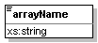

Name of the supplemental data array.

Attributes

Name | Type | Use | Annotation

Children

Element Name | Use | Section

mzData/spectrumList/spectrum/supDataArray/float

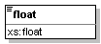

Attributes

Name | Type | Use | Annotation

Children

Element Name | Use | Section

mzData/spectrumList/spectrum/supDataArray/double

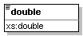

Attributes

Name | Type | Use | Annotation

Children

Element Name | Use | Section

mzData/spectrumList/spectrum/supDataArray/int

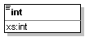

Attributes

Name | Type | Use | Annotation

Children

Element Name | Use | Section

mzData/spectrumList/spectrum/supDataArray/Boolean

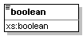

Attributes

Name | Type | Use | Annotation

Children

Element Name | Use | Section

mzData/spectrumList/spectrum/supDataArray/string

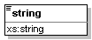

Attributes

Name | Type | Use | Annotation

Children

Element Name | Use | Section

mzData/spectrumList/spectrum/supDataArray/time

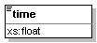

Attributes

Name | Type | Use | Annotation

Children

Element Name | Use | Section

mzData/spectrumList/spectrum/supDataArray/URI

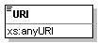

Attributes

Name | Type | Use | Annotation

Children

Element Name | Use | Section

Author Information

Randall K. Julian, Jr., Indigo BioSystems, Inc. rkjulian@indigobio.com
Puneet Souda, University of California Los Angeles. psouda@chem.ucla.edu

Intellectual Property Statement

The PSI takes no position regarding the validity or scope of any intellectual property or other rights that might be claimed to pertain to the implementation or use of the technology described in this document or the extent to which any license under such rights might or might not be available; neither does it represent that it has made any effort to identify any such rights. Copies of claims of rights made available for publication and any assurances of licenses to be made available, or the result of an attempt made to obtain a general license or permission for the use of such proprietary rights by implementers or users of this specification can be obtained from the PSI Secretariat.

The PSI invites any interested party to bring to its attention any copyrights, patents or patent applications, or other proprietary rights which may cover technology that may be required to practice this recommendation. Please address the information to the PSI Executive Director (see contacts information at PSI website).

Full Copyright Notice

Copyright (C) Proteomics Standards Initiative (2006). All Rights Reserved.

This document and translations of it may be copied and furnished to others, and derivative works that comment on or otherwise explain it or assist in its implementation may be prepared, copied, published and distributed, in whole or in part, without restriction of any kind, provided that the above copyright notice and this paragraph are included on all such copies and derivative works. However, this document itself may not be modified in any way, such as by removing the copyright notice or references to the PSI or other organizations, except as needed for the purpose of developing Proteomics Recommendations in which case the procedures for copyrights defined in the PSI Document process must be followed, or as required to translate it into languages other than English.

The limited permissions granted above are perpetual and will not be revoked by the PSI or its successors or assigns.

This document and the information contained herein is provided on an "AS IS" basis and THE PROTEOMICS STANDARDS INITIATIVE DISCLAIMS ALL WARRANTIES, EXPRESS OR IMPLIED, INCLUDING BUT NOT LIMITED TO ANY WARRANTY THAT THE USE OF THE INFORMATION HEREIN WILL NOT INFRINGE ANY RIGHTS OR ANY IMPLIED WARRANTIES OF MERCHANTABILITY OR FITNESS FOR A PARTICULAR PURPOSE.

References

[1] Tim Bray, Jean Paoli, C. M. Sperberg-McQueen, and Eve Maler. Extensible Markup Language (XML) 1.0 (Second Edition). Recommendation, W3C, October 2000. See http://www.w3.org/TR/2000/REC-xml-20001006.

[2] John Cowan and Richard Tobin. XML Information Set. Recommendation, W3C, October 2001. See http://www.w3.org/TR/2001/REC-xml-infoset-20011024/.

[3] Henry S. Thompson, David Beech, Murray Maloney, and Noah Mendelsohn. XML Schema Part 1: Structures. Recommendation, W3C, May 2001. See http://www.w3.org/TR/2001/REC-xmlschema-1-20010502/.

[4] Paul V. Biron and Ashok Malhotra. XML Schema Part 2: Datatypes. Recommendation, W3C, May 2001. See http://www.w3.org/TR/2001/REC-xmlschema-2-20010502/.

[5] T. Berners-Lee, R. Fielding, and L. Masinter. RFC 2396: Uniform Resource Identifiers (URI): Generic Syntax. RFC, IETF, March 1997. See http://www.ietf.org/rfc/rfc2396.txt.

[6] S. Josefsson, Ed., RFC 3548: The Base16, Base32, and Base64 Data Encodings, IETF, July 2003. See http://www.ietf.org/rfc/rfc3548.txt.

Appendix: Controlled Vocabulary Usage

Data items which are implemented as cvParam elements allow flexibility in describing instruments and experiments. Some cvParam elements are required to meet minimum reporting requirements. Below includes the current (PSI-Ont 1.6.1) allowed values for cvParam elements.

mzData/description/admin/sampleDescription

Required | Accession Number | Name | Definition
 | PSI:1000001 | Sample Number | Identifier of the sample under study.
 | PSI:1000002 | Sample Name | A reference string relevant to the sample under study.
 | PSI:1000003 | Sample State | The chemical phase of a pure sample, or the state of a mixed sample.
 | PSI:1000004 | Sample Mass | Total mass of sample used.
 | PSI:1000005 | Sample Volume | Total volume of solution used.
 | PSI:1000006 | Sample Concentration | Total concentration of the sample used.
 | PSI:1000047 | Emulsion | State if the sample is in emulsion form.
 | PSI:1000048 | Gas | State if the sample is in gaseous form.
 | PSI:1000049 | Liquid | State if the sample is in liquid form.
 | PSI:1000050 | Solid | State if the sample is in solid form.
 | PSI:1000051 | Solution | State if the sample is in solution form.
 | PSI:1000052 | Suspension | State if the sample is in suspension form.
 | PSI:1000053 | Batch | Sample batch lot identifier.
 | PSI:1000054 | Chromatography | Chromatographic conditions used to obtain the sample.

mzData/description/instrument/source

Required | Accession Number | Name | Definition
 | PSI:1000007 | Inlet Type | The nature of the sample inlet.
 | PSI:1000008 | Ionization Type | The method by which ions are generated from the sample.
 | PSI:1000009 | Ionization Mode | Please see Polarity Mode.
 | PSI:1000055 | Continuous Flow Fast Atom Bombardment | Fast atom bombardment ionization in which the analyte in solution is entrained in a flowing liquid matrix.
 | PSI:1000056 | Direct | The sample is directly inserted into the ion source, usually on the end of a heatable probe.
 | PSI:1000057 | Electrospray Inlet | Inlet used for introducing the liquid sample into an electrospray ionization source.
 | PSI:1000058 | Flow Injection Analysis | Add definition; Sample is directly injected or infused into the ionization source.
 | PSI:1000059 | Inductively Coupled Plasma | A gas discharge ion source in which the energy to the plasma is supplied by electromagnetic induction.
 | PSI:1000060 | Infusion | The continuous flow of solution of a sample into the ionization source.
 | PSI:1000061 | Jet Separator | A device that separates carrier gas from gaseous analyte molecules on the basis of diffusivity.
 | PSI:1000062 | Membrane Separator | A device to separate carrier molecules from analyte molecules on the basis of ease of diffusion across a semipermeable membrane.
 | PSI:1000063 | Moving Belt | Continous moving surface in the form of a belt which passes through an ionsource carrying analyte molecules.
 | PSI:1000064 | Moving Wire | Continous moving surface in the form of a wire which passes through an ionsource carrying analyte molecules.
 | PSI:1000065 | Open Split | A division of flowing stream of liquid into two streams.
 | PSI:1000066 | Particle Beam | Method for generating ions from a solution of an analyte.
 | PSI:1000067 | Reservoir | A sample inlet method involving a reservoir.
 | PSI:1000068 | Septum | A disc composed of a flexible material that seals the entrance to the reservoir. Can also be enterance to the vaccum chamber.
 | PSI:1000069 | Thermospray Inlet | A method for generating gas phase ions from a solution of an analyte by rapid heating of the sample.
 | PSI:1000070 | Atmospheric Pressure Chemical Ionization | Chemical ionization that takes place at atmospheric pressure as opposed to the reduced pressure is normally used for chemical ionization.
 | PSI:1000071 | Chemical Ionization | The formation of a new ion by the reaction of a neutral species with an ion. The process may involve transfer of an electron\, a proton or other charged species between the reactants. When a positive ion results from chemical ionization the term may be used without qualification. When a negative ion results the term negative ion chemical ionization should be used. Note that this term is not synonymous with chemi-ionization.
 | PSI:1000072 | Electronic Ionization | The ionization of an atom or molecule by electrons that are typically accelerated to energies between 50 and 150 eV. Usually 70 eV electrons are used to produce positive ions. The term 'electron impact' is not recommended.
 | PSI:1000073 | Electrospray Ionization | A process in which ionized species in the gas phase are produced from an analyte-containing solution via highly charged fine droplets\, by means of spraying the solution from a narrow-bore needle tip at atmospheric pressure in the presence of a high electric field. When a pressurized gas is used to aid in the formation of a stable spray\, the term pneumatically assisted electrospray ionization is used. The term ion spray is not recommended.
 | PSI:1000074 | Fast Atom Bombardment Ionization | The ionization of any species by the interaction of a focused beam of neutral atoms having a translational energy of several thousand eV with a sample that is typically dissolved in a solvent matrix. See also secondary ionization.
 | PSI:1000075 | Matrix-assisted Laser Desorption Ionization | The formation of gas-phase ions from molecules that are present in a solid or solvent matrix that is irradiated with a pulsed laser. See also laser desorption/ionization.
 | PSI:1000076 | Negative Ion Mode | Operation of the mass spectrometer to generate negative ions.
 | PSI:1000077 | Positive Ion Mode | Operation of the mass spectrometer to generate positive ions.
 | PSI:1000239 | Atmospheric Pressure Matrix-Assisted Laser Desorption Ionization | Matrix-assisted laser desorption ionization in which the sample target is at atmospheric pressure and the ions formed by the pulsed laser are sampled through a small aperture into the mass spectrometer.
 | PSI:1000240 | Atmospheric Pressure Ionization | Any ionization process in which ions are formed in the gas phase at atmospheric pressure.
 | PSI:1000241 | Atmostpheric Pressure Photoionization | Atmospheric pressure chemical ionization in which the reactant ions are generated by photo-ionization.
 | PSI:1000247 | Desorption Ionization | The formation of ions from a solid or liquid material after the rapid vaporization of that sample.
 | PSI:1000248 | Direct Insertion Probe | A device for introducing a solid or liquid sample into a mass spectrometer ion source for desorption ionization.
 | PSI:1000249 | Direct Liquid Introduction | The delivery of a liquid sample into a mass spectrometer for spray or desorption ionization.

mzData/description/instrument/analyzerList/analyzer

Required | Accession Number | Name | Definition
 | PSI:1000010 | Analyzer Type | The common name of the particular analyzer stage being described.
 | PSI:1000011 | Mass Resolution | The maximum m/z value at which two peaks can be resolved, according to one of the standard measures.
 | PSI:1000012 | Resolution Method | Which of the available standard measures is used to define whether two peaks are separate.
 | PSI:1000013 | Resolution Type | Specify the nature of resolution for the mass analyzer. Resolution is usually either constant with respect to m/z or proportional to m/z.
 | PSI:1000014 | Accuracy | Accuracy of mass assignment.
 | PSI:1000015 | Scan Rate | Rate in (m/z)/sec for scanning analyzers.
 | PSI:1000016 | Scan Time | Time taken for an acquisition for scanning analyzers.
 | PSI:1000017 | Scan Function | Describes the type of mass analysis being performed. Two primary modes are typical acquisition over a range of masses (MassScan), and Selection Ion Detection. The primary difference is that Selected Ion Detection produces a single value for the signal at the selected mass rather than producing a mass spectrum.
 | PSI:1000018 | Scan Direction | Direction in terms of m/z of the scan for scanning analyzers (low to high, or high to low).
 | PSI:1000019 | Scan Law | Describes the function in control of the m/z scan (for scanning instruments). Commonly the scan function is linear, but in principle any function can be used.
 | PSI:1000020 | Tandem Scanning Method | Describes the acquisition data type produced by a tandem mass spectrometry experiment.
 | PSI:1000021 | Reflectron State | Status of the reflectron, turned on, off or no reflectron.
 | PSI:1000022 | TOF Total Path Length | The length of the field free drift space in a time of flight mass spectrometer.
 | PSI:1000023 | Isolation Width | The total width (i.e. not half for plus-or-minus) of the gate applied around a selected precursor ion.
 | PSI:1000024 | Final MS Exponent | The final ‘MS level’ achieved when performing PFF with the ion trap (e.g. MS^10).
 | PSI:1000025 | Magnetic Field Strength | A property of space that produces a force on a charged particle equal to qv x B where q is the particle charge and v its velocity
 | PSI:1000078 | Axial Ejection Linear Ion Trap | A linear ion trap mass spectrometer where ions are ejected along the axis of the analyzer.
 | PSI:1000079 | Fourier Transform Ion Cyclotron Resonance Mass Spectrometer | A mass spectrometer based on the principle of ion cyclotron resonance in which an ion in a magnetic field moves in a circular orbit at a frequency characteristic of its m/z value. Ions are excited to a coherent orbit using a pulse of radio frequency energy and their image charge is detected on receiver plates as a time domain signal. Fourier transformation of the time domain signal results in a frequency domain signal which is converted to a mass spectrum based in the inverse relationship between frequency and m/z.
 | PSI:1000080 | Magnetic Sector | A device that produces a magnetic field perpendicular to a charged particle beam that deflects the beam to an extent that is proportional to the particle momentum per unit charge. For a monoenergetic beam, the deflection is proportional to m/z.
 | PSI:1000081 | Quadrupole | A mass spectrometer that consists of four parallel rods whose centers form the corners of a square and whose opposing poles are connected. The voltage applied to the rods is a superposition of a static potential and a sinusoidal radio frequency potential. The motion of an ion in the x and y dimensions is described by the Matthieu equation whose solutions show that ions in a particular m/z range can be transmitted along the z axis.
 | PSI:1000082 | Quadrupole Ion Trap | Quadrupole Ion Trap mass analyzer captures the ions in a three dimensional ion trap and then selectively ejects them by varying the RF and DC potentials.
 | PSI:1000083 | Radial Ejection Linear Ion Trap | A linear ion trap mass spectrometer where ions are ejected along the radius of the analyzer.
 | PSI:1000084 | Time-of-flight | An instrument that separates ions by m/z in a field-free region after acceleration to a fixed kinetic energy.
 | PSI:1000085 | Baseline | An attribute of resolution when recording the detector response in absence of the analyte.
 | PSI:1000086 | Full Width at Half-Maximum | A measure of resolution represented as width of the peak at half peak height.
 | PSI:1000087 | Ten Percent Valley | An attribute of resolution when the ratio between adjacent signals is 10% of the signal height.
 | PSI:1000088 | Constant | When resolution is constant with respect to m/z.
 | PSI:1000089 | Proportional | When resolution is proportional with respect to m/z.
 | PSI:1000090 | Mass Scan | A variation of instrument where a selected mass is scanned.
 | PSI:1000091 | Selected Ion Detection | Please see Single Ion Monitoring.
 | PSI:1000092 | Down | Direction of mass scan.
 | PSI:1000093 | Up | Direction of mass scan.
 | PSI:1000094 | Exponential | The mass scan is done in exponential mode.
 | PSI:1000095 | Linear | The mass scan is done in linear mode.
 | PSI:1000096 | Quadratic | The mass scan is done in quadratic mode.
 | PSI:1000097 | Constant Neutral Mass Loss | A spectrum formed of all product ions that have been produced with a selected m/z decrement from any precursor ions. The spectrum shown correlates to the precursor ion spectrum. See also neutral loss spectrum.
 | PSI:1000098 | Multiple Ion Monitoring | Data acquired when monitoring the ion current of a few specific m/z values.
 | PSI:1000099 | Multiple Reaction Monitoring | This term is not recommended. See Selected Reaction Monitoring.
 | PSI:1000100 | Precursor Ion Scan | The specific scan function or process that records a precursor ion spectrum.
 | PSI:1000101 | Product Ion Scan | The specific scan function or process that records product ion spectrum.
 | PSI:1000102 | Single Ion Monitoring | The operation of a mass spectrometer to monitor a single ion rather than scanning entire mass spectrum.
 | PSI:1000103 | Single Reaction Monitoring | See Selected Reaction Monitoring.
 | PSI:1000104 | None | None
 | PSI:1000105 | Off | Off
 | PSI:1000106 | On | On
 | PSI:1000206 | Selected Reaction Monitoring | Data acquired from specific product ions corresponding to m/z selected precursor  ions recorded via two or more stages of mass spectrometry. Selected reaction monitoring can be preformed as tandem mass spectrometry in time or tandem mass spectrometry in space.

mzData/description/instrument/detector

Required | Accession Number | Name | Definition
 | PSI:1000026 | Detector Type | The type of the detector used to detect the ions in the mass spectrometer.
 | PSI:1000027 | Detector Acquisition Mode | Method by which detector signal is acquired by the data system.
 | PSI:1000028 | Detector Resolution | The resolving power of the detector to differentiate between ions of two different m/z values.
 | PSI:1000029 | Sampling Frequency | The rate of signal sampling (measurement) with respect to time.
 | PSI:1000107 | Channeltron | A horn-shaped continuous dynode particle multiplier. The ion strikes the inner surface of the device and induces the production of secondary electrons that in turn impinge on the inner surfaces to produce more secondary electrons. This avalanche effect produces an increase in signal in the final measured current pulse. (Note that Channeltron® is a registered trademark.
 | PSI:1000108 | Conversion Dynode Electron Multiplier | A surface that is held at high potential so that ions striking the surface produce electrons that  are subsequently detected.
 | PSI:1000109 | Conversion Dynode Photomultiplier | A detector in which ions strike a conversion dynode to produce electrons that in turn generate photons through a phosphorescent screen that are detected by a photomultiplier.
 | PSI:1000110 | Daly Detector | A metal knob held at high potential that emits secondary electrons when ions impinge on the surface. The secondary electrons are accelerated onto a scintillator that produces light that is then detected by a photomultiplier detector.
 | PSI:1000111 | Electron Multiplier Tube | A series of biased dynodes ejects secondary electrons when struck by an ion.
 | PSI:1000112 | Faraday Cup | A conducting cup or chamber that intercepts a charged particle beam and is electrically connected to a current measuring device.
 | PSI:1000113 | Focal Plane Array | A detector for spatially disperse ion beams in which all ions simultaneously impinge on the detector plane.
 | PSI:1000114 | Microchannel Plate Detector | A thin plate that contains a closely spaced array of channels that each act as a continuous dynode particle multiplier. A charged particle\, fast neutral particle\, or photon striking the plate causes a cascade of secondary electrons that ultimately exits the opposite side of the plate.
 | PSI:1000115 | Multi-Collector | A detector system commonly used in inductively coupled plasma mass spectrometers.
 | PSI:1000116 | Photomultiplier | A detector for conversion of the ion/electron signal into photon(s) which are then amplified and detected.
 | PSI:1000117 | Analog-Digital Converter | A detector acquisition mode that uses an ADC to converts voltage to a binary digital number.
 | PSI:1000118 | Pulse Counting | Pulse counting.
 | PSI:1000119 | Time-Digital Converter | A device for converting a signal of sporadic pluses into a digital representation of their time indices.
 | PSI:1000120 | Transient Recorder | A detector acquisition mode used for detecting transient signals.
 |  | Polarity Mode | A detector acquisition mode to which specifies weather polarity is negative or positive.

mzData/description/instrument/additional

Required | Accession Number | Name | Definition
 | PSI:1000030 | Vendor | Name of instrument vendor.
 | PSI:1000031 | Model | Instrument's model name (everything but the vendor's name).
 | PSI:1000032 | Customization | Free text description of a single customization made to the instrument; for several modifications, use several entries.

mzData/description/dataProcessing/processingMethod

Required | Accession Number | Name | Definition
 | PSI:1000033 | Deisotoping | Deisotoping is removal of isotopes to represent the fragment ion as one data point and is commonly done to reduce complexity. It is done in conjunction with the charge state deconvolution.
 | PSI:1000034 | Charge Deconvolution | The determination of the mass of an ion based on the mass spectral peaks that represent multiple-charge ions.
 | PSI:1000035 | Peak Processing | Spectral peak processing done on the acquired data.

mzData/spectrumList/spectrum/spectrumDesc/spectrumInstrument

Required | Accession Number | Name | Definition
 | PSI:1000037 | Polarity mode * | Polarity as described in negative ion or positive ion mode.
 | PSI:1000038 | Time In Minutes | Acquisition time in minutes
 | PSI:1000039 | Time In Seconds | Acquisition time in seconds

* In addition to time, polarity mode could be listed if polarity alternates during the experiment.

mzData/spectrumList/spectrum/spectrumDesc/spectrumSettings/acquisitionSpecification/acquisition

mzData/spectrumList/spectrum/spectrumDesc/precursorList/precursor/ionSelection

Required | Accession Number | Name | Definition
 | PSI:1000040 | Mass To Charge Ratio | The symbol m/z is used to denote the dimensionless quantity formed by dividing the mass of an ion in atomic units by its charge number. The symbol is italicized lower case letters with no spaces
 | PSI:1000041 | Charge State | The charge state of the ion, single or multiple and positive or negatively charged.
 | PSI:1000042 | Intensity | Intensity of ions as measured by the height or area of a peak in a mass spectrum.
 | PSI:1000043 | Intensity Units | Intensity units are commonly arbitrary. Detected in counts per second (cps) when using counting detectors, but measured in volts when using analog detectors.

mzData/spectrumList/spectrum/spectrumDesc/precursorList/precursor/activation

Required | Accession Number | Name | Definition
 | PSI:1000044 | Method | Fragmentation method used for dissociation or fragmentation.
 | PSI:1000045 | Collision Energy | Energy for an ion experiencing collision with a stationary gas particle resulting in dissociation of the ion. Projectile ions
 | PSI:1000046 | Energy Units | Energy units are represented in either eV or Joules.
 | PSI:1000242 | Blackbody Infrared Radiative Dissociation | A special case of infrared multiphoton dissociation wherein excitation of the reactant ion is caused by absorption of infrared photons radiating from heated blackbody surroundings, which are usually the walls of a vacuum chamber. See also infrared multiphoton dissociation.
 | PSI:1000243 | Charge-Remote Fragmentation | A fragmentation of an even-electron ion in which the cleaved bond is not adjacent to the apparent charge site.
 | PSI:1000244 | Consecutive Reaction Monitoring | A type of MS/MS experiments with three or more stages of m/z separation and in which a particular multi-step reaction path is monitored.
 | PSI:1000245 | Charge Stripping | The reaction of a positive ion with an atom or molecule that results in the removal of one or more electrons from the ion.
 | PSI:1000246 | Delayed Extraction | The application of the accelerating voltage pulse after a time delay in desorption ionization from a surface. The extraction delay can produce energy focusing in a time-of-flight mass spectrometer.
 | PSI:1000250 | Electron Capture Dissociation | A process in which a multiply protonated molecules interacts with a low energy electrons. Capture of the electron leads the liberation of energy and a reduction in charge state of the ion with the production of the (M + nH) (n-1)+ odd electron ion, which readily fragments.

mzData/spectrumList/spectrum/supDesc/supDataDesc

References for Terms:

- Kinter, M. and Sherman, N.E. (2000) Protein Sequencing and Identification Using Tandem Mass Spectrometry, Wiley-Interscience, John Wiley and Sons, Inc., publication, New York.
- Sparkman, O.D. (2000) Mass Spectrometry Desk Reference, 1st Ed., Global View Publishing, Pittsburgh, Pennsylvania.
- Grayson, M (2002) Measuring Mass From Positive Rays to Proteins (Grayson M.A. ed), American Society of Mass Spectrometry, Santa Fe, New Mexico.
- Gentzel M., Köcher T., Ponnusamy S., Wilm M. Preprocessing of tandem mass spectrometric data to support automatic protein identification, Proteomics 2003, 3, 1597–1610. PMID: 12923784
- Murray K.K., Boyd R.K, Eberlin M.N.,Langley G.J., Liang L., Naito Y.; Standard definitions of terms relating to mass spectrometry; second draft May 2006. International Union of Pure and Applied Chemistry, Analytical Chemistry devision.

Appendix: Base64 Encoded Data Read/Write Example

This example was written by Kai Runte and uses the Apache Commons Codec Project: http://jakarta.apache.org/commons/codec/ to implement the base64 encoding.

import java.util.List;
import java.util.Vector;

import org.apache.commons.codec.DecoderException;
import org.apache.commons.codec.EncoderException;
import org.apache.commons.codec.binary.Base64;

/**
*
* @author Kai Runte
*/

public class Base64Util {

public static String floatListToBase64String(List floatList, boolean bigEndian) throws EncoderException {
byte[] raw = floatListToByteArray(floatList, bigEndian);
Base64 base64 = new Base64();
byte[] encoded = base64.encode(raw);
return new String(encoded);
}

/**
* Returns a byte array representing the float values in the IEEE
* 754 floating-point "single format" bit layout.
* @param floatList a list of float values
* @param bigEndian
* @return a byte array representing the float values in the
* IEEE 754 floating-point "single format" bit layout.
*/
public static byte[] floatListToByteArray(List floatList,
boolean bigEndian) {
int floatListSize = floatList.size();
byte[] raw = new byte[floatListSize * 4];
int jjj = 0;
if (bigEndian) {
for (int iii = 0; iii < floatListSize; iii++) {
Float aFloat = (Float) floatList.get(iii);
int ieee754 = Float.floatToIntBits(aFloat.floatValue());
raw[jjj] = (byte) ((ieee754 >> 24) & 0xff);
raw[jjj + 1] = (byte) ((ieee754 >> 16) & 0xff);
raw[jjj + 2] = (byte) ((ieee754 >> 8) & 0xff);
raw[jjj + 3] = (byte) ((ieee754) & 0xff);
jjj += 4;
}
} else {
for (int iii = 0; iii < floatListSize; iii++) {
Float aFloat = (Float) floatList.get(iii);
int ieee754 = Float.floatToIntBits(aFloat.floatValue());
raw[jjj] = (byte) ((ieee754) & 0xff);
raw[jjj + 1] = (byte) ((ieee754 >> 8) & 0xff);
raw[jjj + 2] = (byte) ((ieee754 >> 16) & 0xff);
raw[jjj + 3] = (byte) ((ieee754 >> 24) & 0xff);
jjj += 4;
}
}
return raw;
}

public static List base64StringToFloatList(String base64String, boolean bigEndian) throws DecoderException {
Base64 base64 = new Base64();
byte[] encoded = base64String.getBytes();
byte[] raw = base64.decode(encoded);
List floatList = byteArrayToFloatList(raw, bigEndian);
return floatList;
}

public static List byteArrayToFloatList(byte[] raw,
boolean bigEndian) {
Vector floatList = new Vector();
if (bigEndian) {
for (int iii = 0; iii < raw.length; iii += 4) {
int ieee754 = 0;
ieee754 |= (((int) raw[iii]) & 0xff);
ieee754 <<= 8;
ieee754 |= (((int) raw[iii + 1]) & 0xff);
ieee754 <<= 8;
ieee754 |= (((int) raw[iii + 2]) & 0xff);
ieee754 <<= 8;
ieee754 |= (((int) raw[iii + 3]) & 0xff);
float aFloat = Float.intBitsToFloat(ieee754);
floatList.add(new Float(aFloat));
}
} else {
for (int iii = 0; iii < raw.length; iii += 4) {
int ieee754 = 0;
ieee754 |= (((int) raw[iii + 3]) & 0xff);
ieee754 <<= 8;
ieee754 |= (((int) raw[iii + 2]) & 0xff);
ieee754 <<= 8;
ieee754 |= (((int) raw[iii + 1]) & 0xff);
ieee754 <<= 8;
ieee754 |= (((int) raw[iii]) & 0xff);
float aFloat = Float.intBitsToFloat(ieee754);
floatList.add(new Float(aFloat));
}
}
return floatList;
}
}

